This guide will walk you through deploying and validating Knative (Serving + Eventing), running Knative Functions locally, and verifying core Serving/Eventing functionalities in the Windows PowerShell environment. It includes fully executable commands, key notes, and troubleshooting solutions tailored for the Windows system.
Prerequisites
- Docker Desktop is installed on Windows (WSL2 backend must be enabled: Docker Desktop -> Settings -> General -> Use the WSL 2 based engine)
- kubectl is installed (via choco install kubernetes-cli or official download)
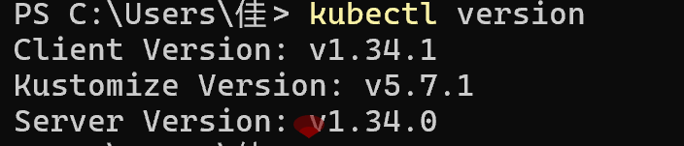
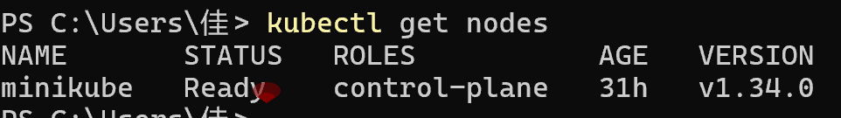
- minikube is installed (via choco install minikube)
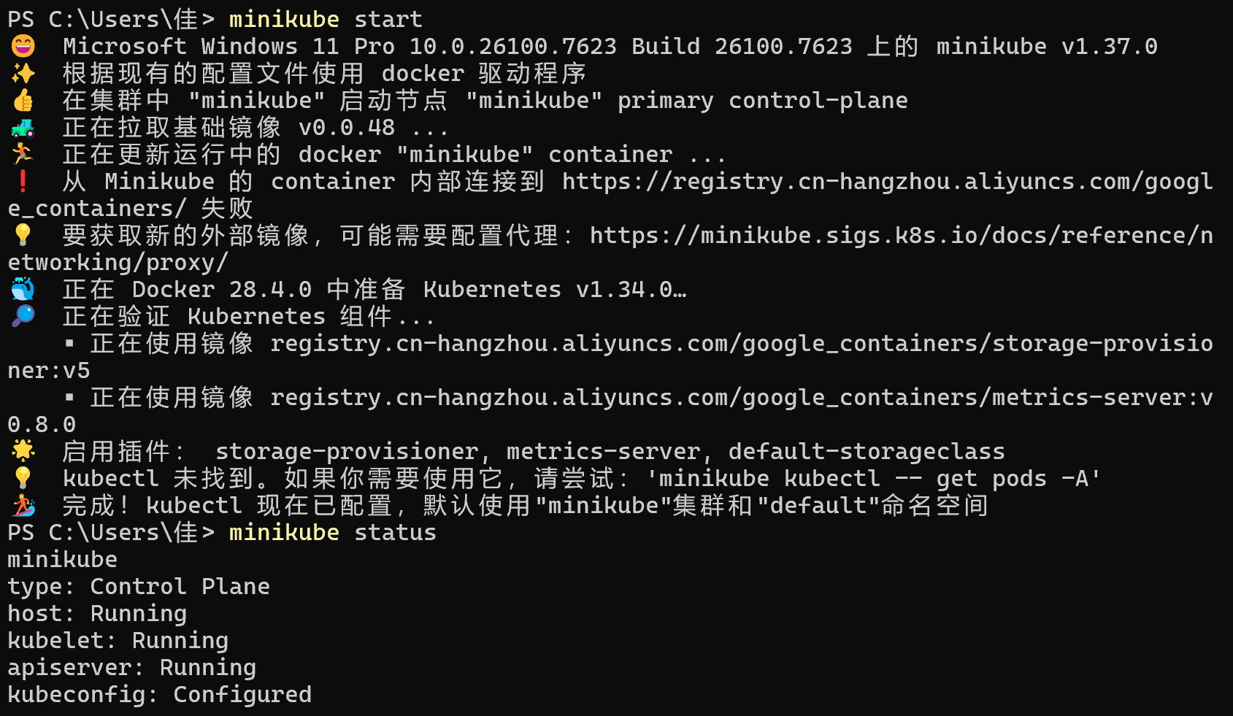
- Knative func CLI is installed (download from: https://github.com/knative/func/releases, extract the Windows version and add the executable path to the system PATH environment variable)
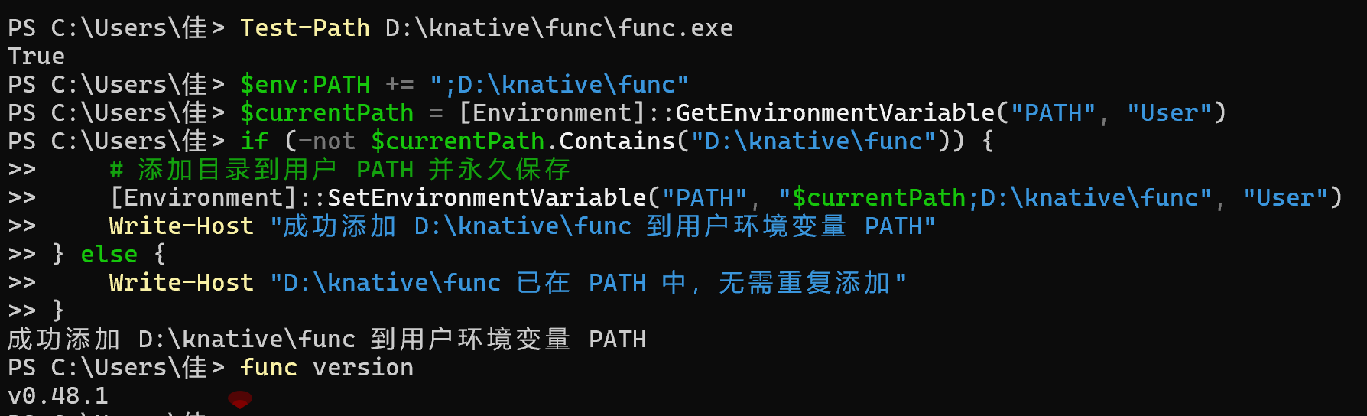
- Step 1: Start the Minikube Cluster
Operation Commands

- Step 2: Install Knative Serving
- Download and Apply Serving CRDs and Core Components
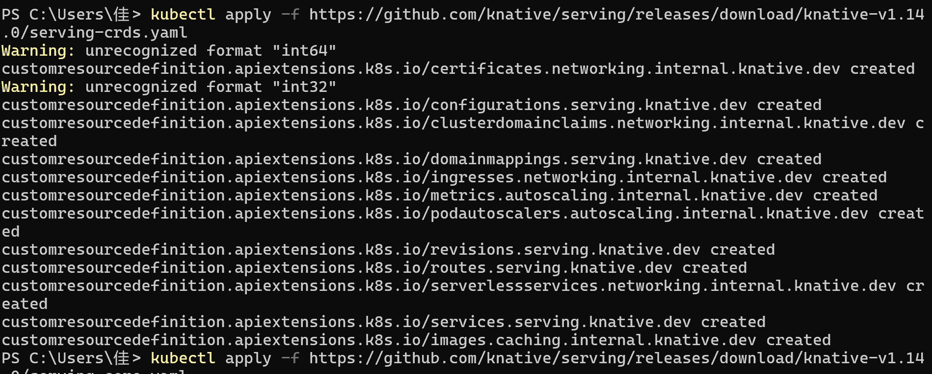
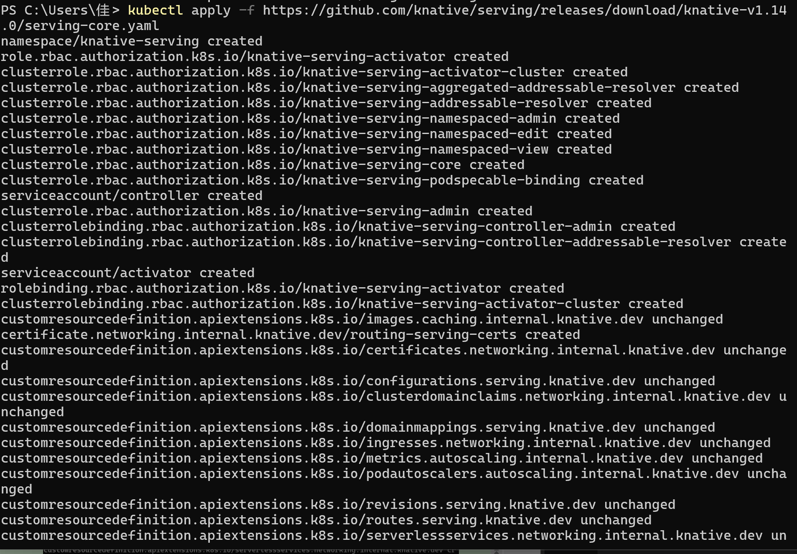
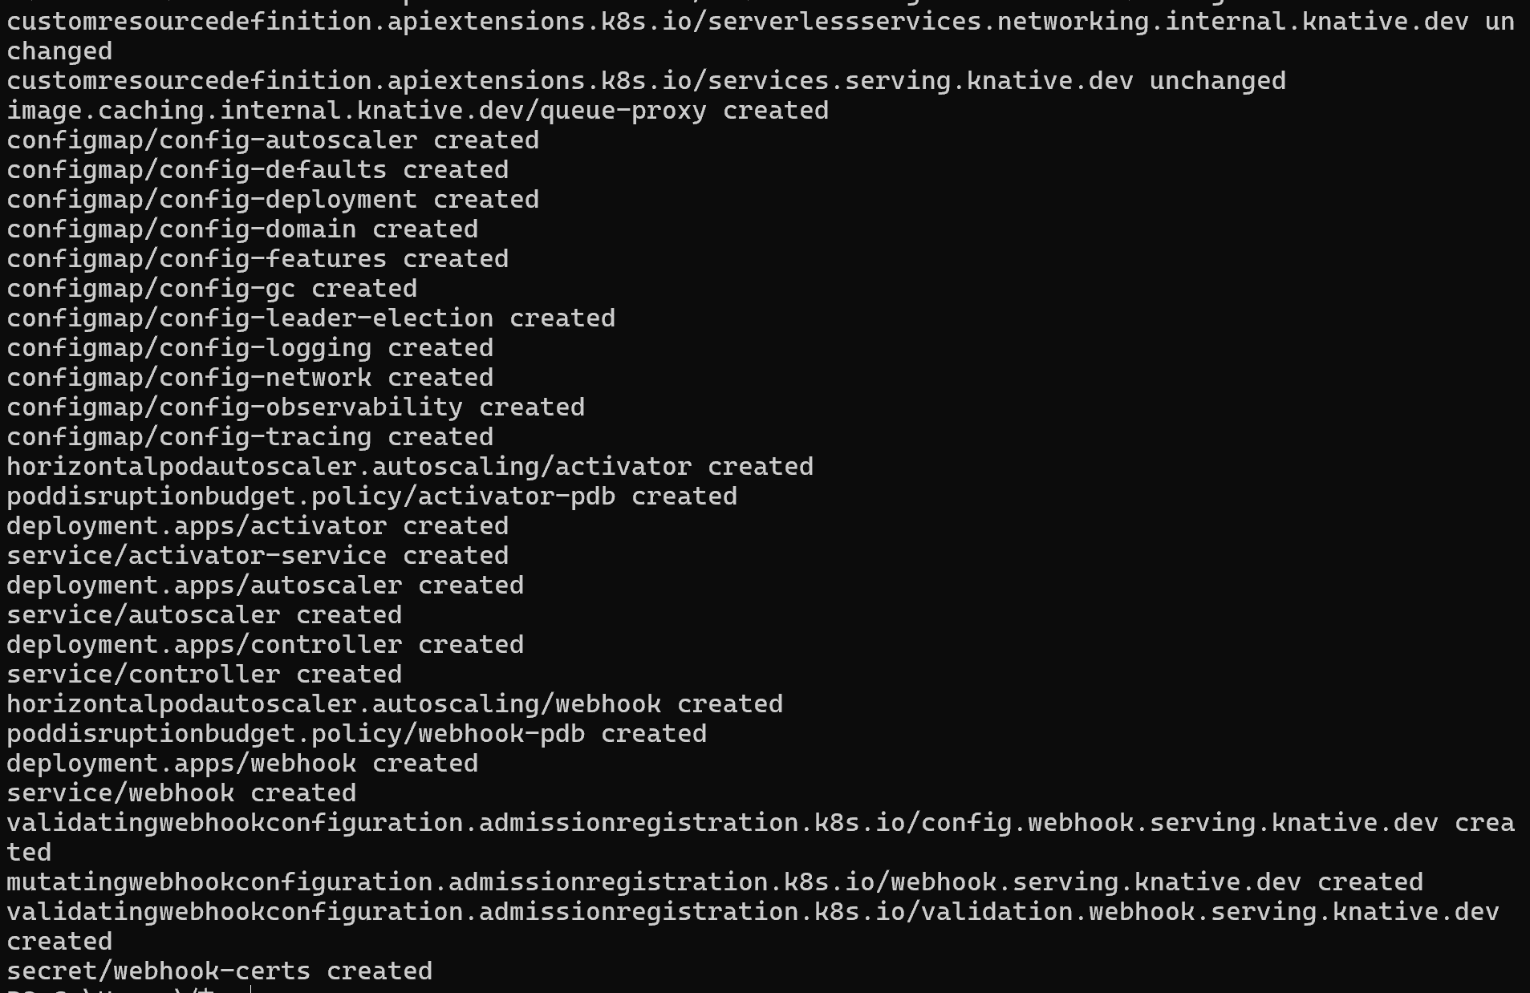

- Install the Istio Network Layer
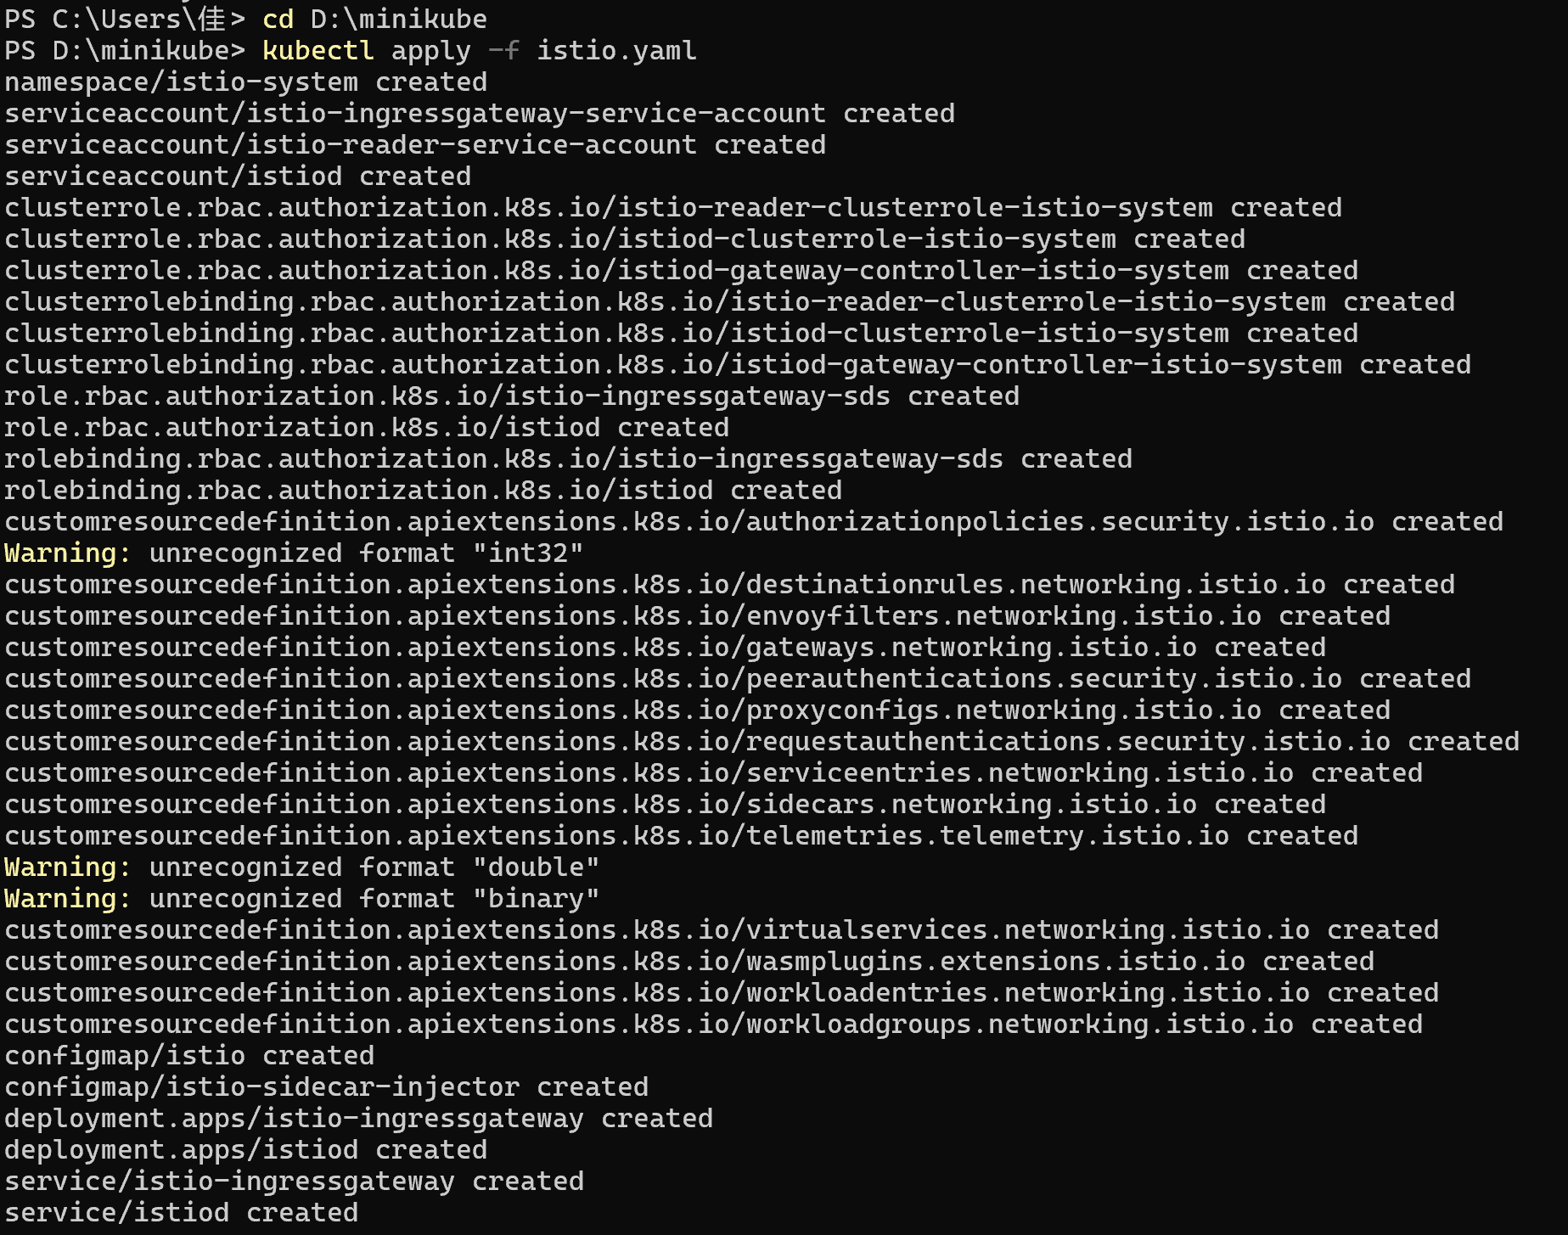
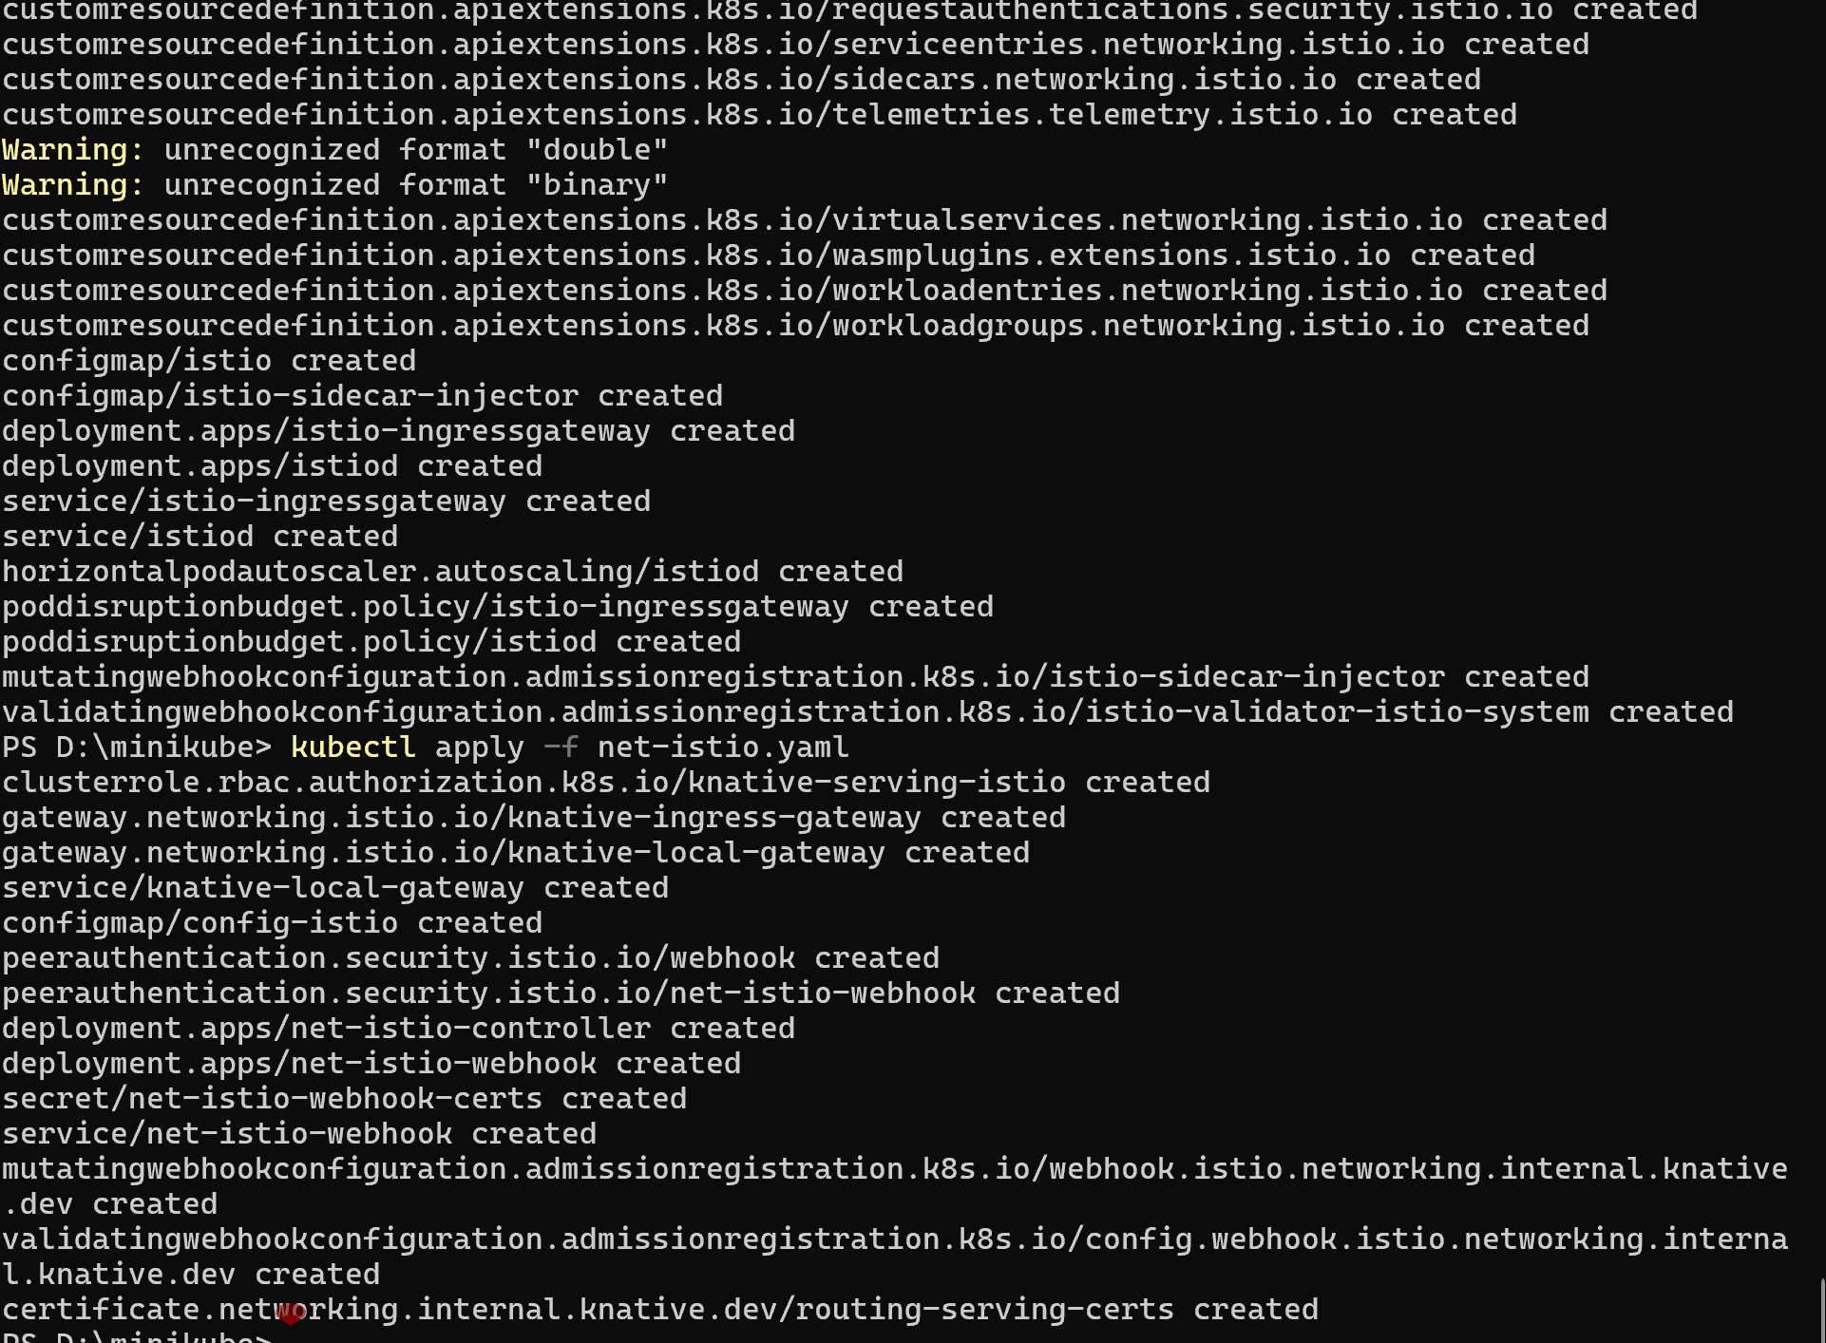

- Install Cert-Manager (Optional, for HTTPS)
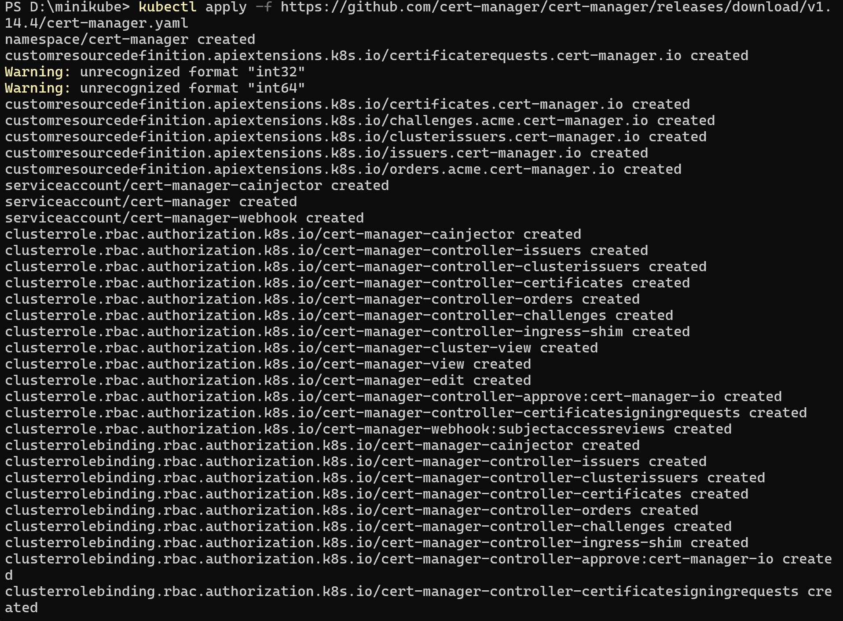
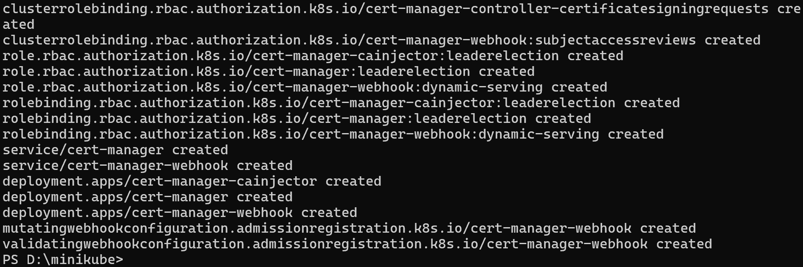
- Step 3: Install Knative Eventing
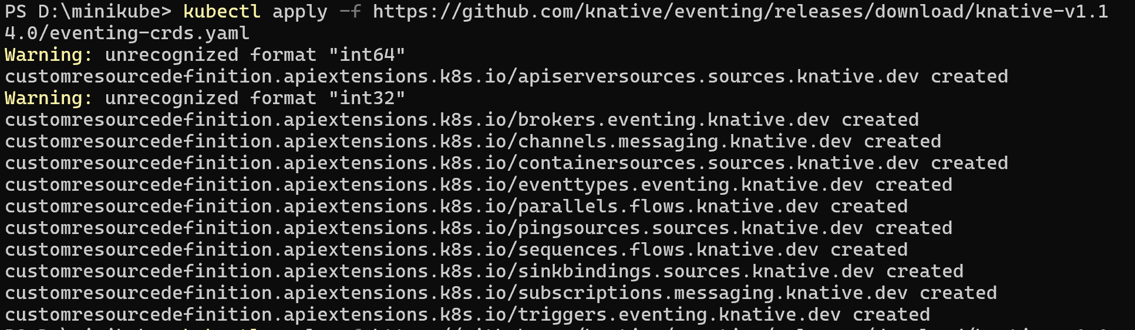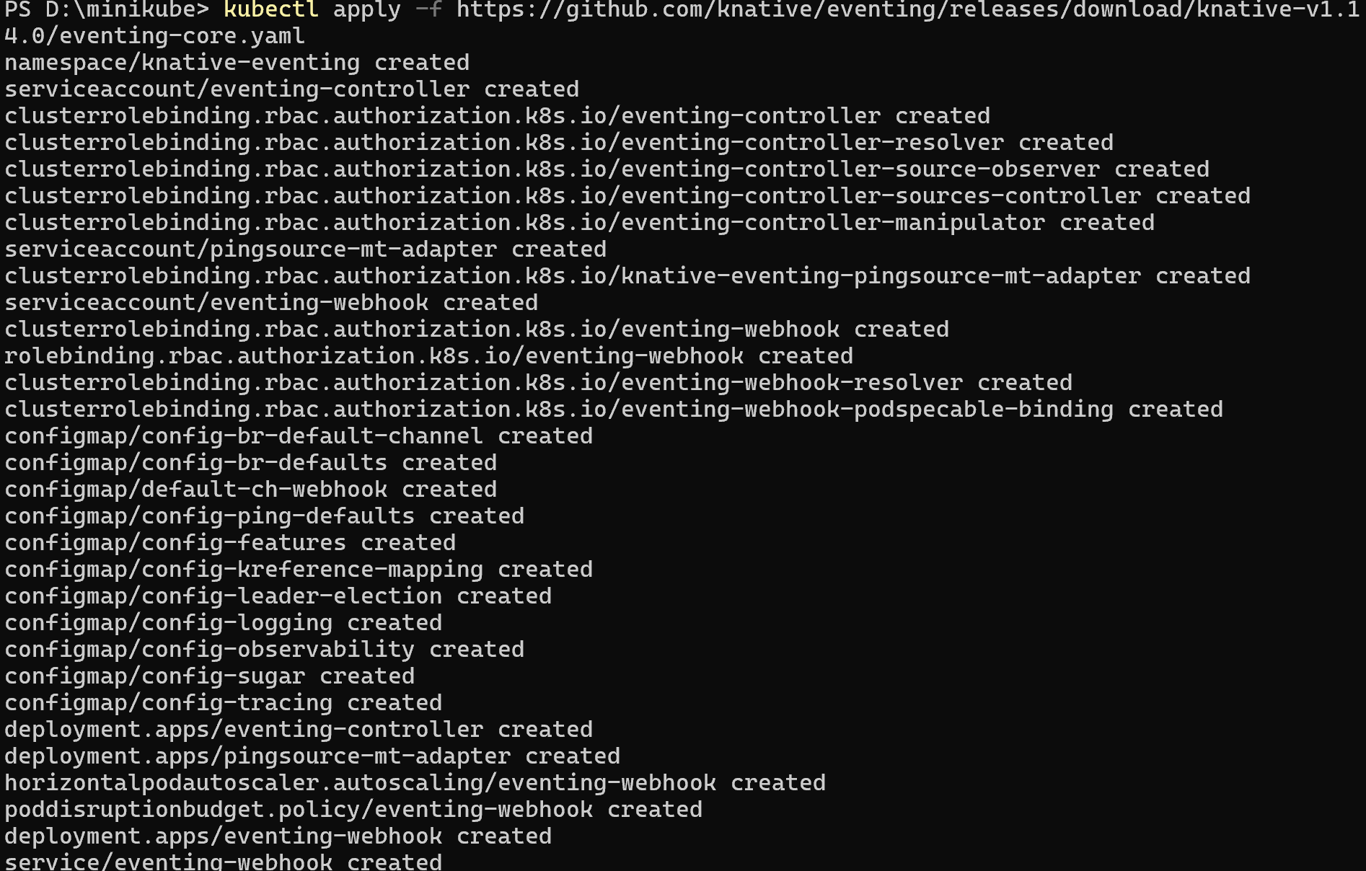
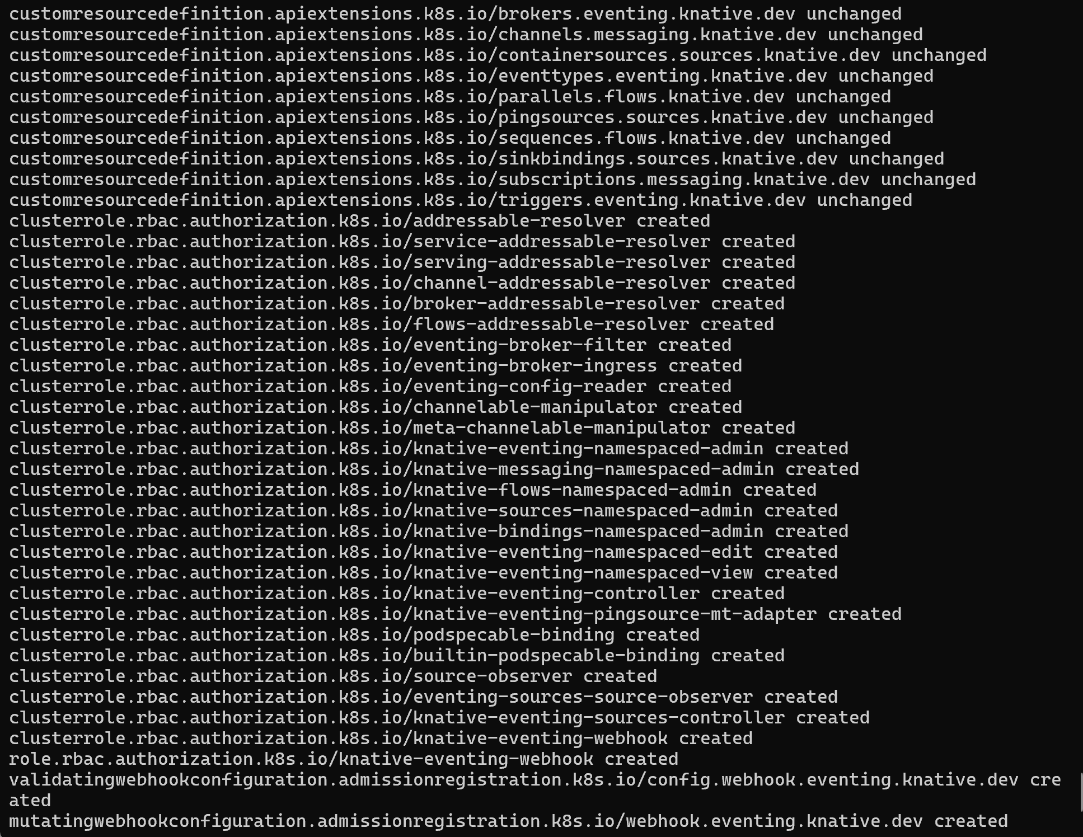
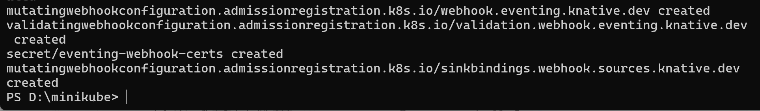

- Step 4: Knative Functions Operations (Local Run, Skip Deployment)
- Verify func CLI Installation
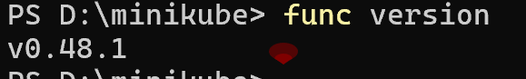
- Create a Go Language Function
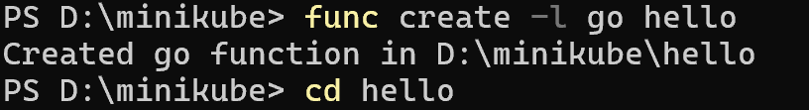
- Start a Local Docker Image Registry
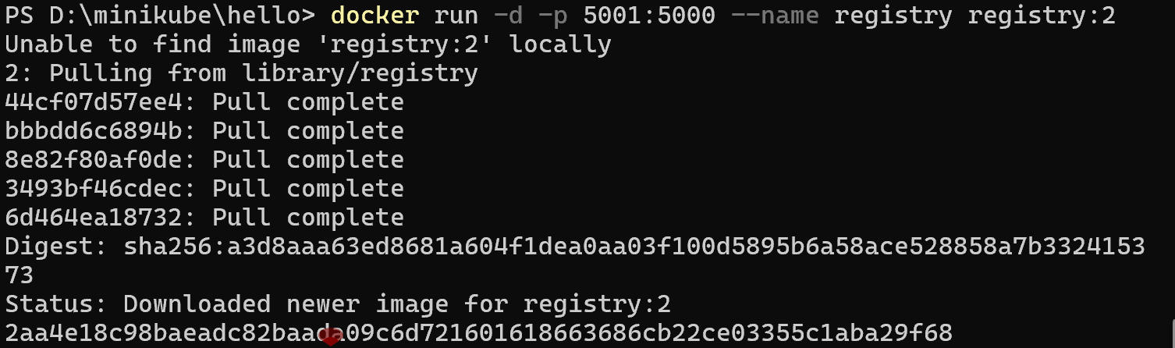
- Run the Function Locally (Specify Local Registry)
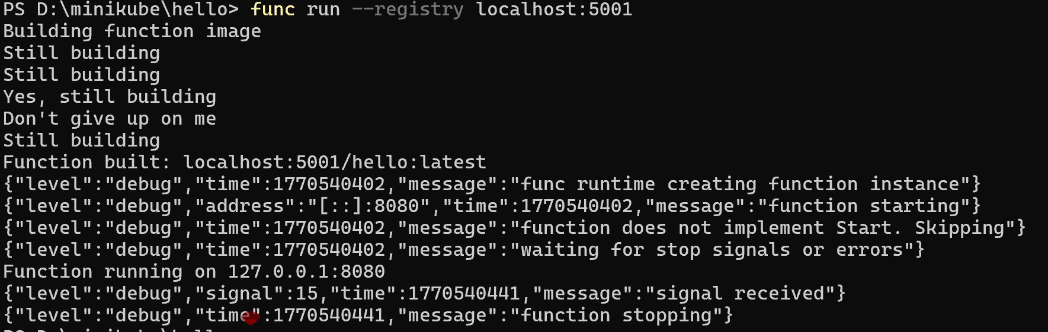
- Build the Function Image (Fix Typo in the Reference Command)
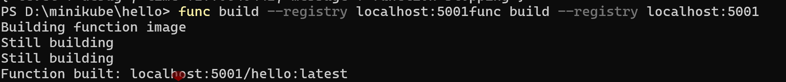

- Step 5: Knative Eventing Validation (Event Sending and Receiving)
- Create an Event Source and a Sink
- View Event Reception Logs
